GROUP-16
Project Proposal Document

1. Project Title:
Enhancing Customer Service with Agent-powered Chatbots

2. Brief problem statement:
This project aims to develop an intelligent multi-agent customer service chatbot system for e-commerce platforms using Large Language Models (LLMs), Retrieval-Augmented Generation (RAG), and agentic AI workflows. The system will provide fast, personalized, and context-aware customer support across multiple customer touchpoints such as chat interfaces, customer support portals, and web applications. E-commerce platforms often struggle to handle large volumes of customer queries efficiently. Traditional chatbots frequently fail to provide accurate, contextual, and personalized responses, resulting in poor customer satisfaction, delayed issue resolution, and increased support costs. Businesses also face challenges in managing complex customer scenarios such as order tracking, refunds, returns, product recommendations, and escalation handling. The proposed system will leverage multi-agent architecture, intelligent reasoning strategies, and dynamic knowledge retrieval to automate customer support workflows and improve overall customer experience.

3. Background information: Include domain information, problem description and analysis, possible applications

4. Motivation for selection of the project
- Focus on agentic AI systems, a cutting-edge and industry-relevant approach | Strong alignment with LLMs, RAG, and multi-agent architectures - Opportunity to Implement Course Learning
- Company Alignment - Relevance & High Applicability | Not a domain outside Team strength, for Validation & Other purposes

5. Detailed dataset description and dataset source
The project will utilize a combination of publicly available and synthetic datasets:
1. Customer Service Conversations:
- Source: Kaggle's Customer Support on Twitter dataset
- Content: Real customer service interactions from various companies
2. E-commerce Product Catalog:
- Source: Amazon product dataset (a subset focused on electronics and home appliances)
- Content: Product descriptions, specifications, prices, and customer reviews
3. Synthetic E-commerce Queries:
- Source: Generated using GPT-5 or similar language models
- Content: Simulated customer queries specific to e-commerce scenarios

6. Current benchmark: provide references (if any)

7. Proposed Plan:
● Define the methodology, including:
Phase | Module | Key Components
Foundation | Setup | Repo, config, logging
 | Data Prep | Load, clean, normalize text
 | Synthetic Data | Prompting, query generation
 | Embeddings | Chunking + ChromaDB storage
Core Build | RAG | Retrieval + grounded responses
 | Router | Intent classification (product/order/return/recommend)
 | Agents | Product (RAG), Order (lookup), Return (policy), Recommend (filters)
 | Orchestrator | Routing, multi-step handling, fallback
 | Memory | Session + chat history
Integration | Tools | Mock order APIs
 | Demo | Notebook testing
 | UI | Gradio chatbot
 | Monitoring | Logging + error handling
Testing | Evaluation | Metrics + RAGAS
 | Testing | Agent + pipeline validation
 | Optimization | Prompt tuning + hallucination reduction
Delivery | Deployment | Local / HF Spaces
 | Docs & Demo | README, diagrams, walkthrough

Agentic E-Commerce Architecture
Order Tracking Workflow
- Customer submits order status inquiry
- Identify customer and order
- Retrieve order and shipment details
- Fetch carrier tracking information
- Analyze shipment status and ETA
- Provide status update and recommendations
- Escalate delivery exceptions if required

Returns & Refunds Workflow
- Customer requests return, refund, exchange, or replacement
- Validate order and purchase information
- Assess return eligibility and policy compliance
- Determine resolution path (refund, exchange, replacement)
- Initiate return request and logistics activities
- Process refund or replacement
- Monitor completion and notify customer
- Capture feedback and close case

Escalation Handling Workflow
- Analyze customer interaction
- Detect dissatisfaction, risk, or exception scenario
- Assess severity and business impact
- Generate case summary and supporting evidence
- Route to appropriate support team
- Monitor SLA and resolution progress
- Close escalation upon resolution

Product Recommendation Workflow
- Capture customer intent and context
- Retrieve customer profile and behavioral data
- Analyze preferences and purchase history
- Generate recommendation candidates
- Rank products using recommendation models
- Present personalized recommendations
- Capture engagement and feedback signals

Agent Orchestrator Workflow
- Receive customer request
- Classify intent(s)
- Decompose request into executable tasks
- Assign tasks to specialized agents
- Coordinate agent collaboration and handoffs
- Collect outputs from participating agents
- Generate consolidated response
- Update context memory and workflow logs

Delayed Order Refund Workflow
- Customer reports delayed order and requests refund
- Order Tracking Agent verifies shipment status
- Returns & Refunds Agent validates refund eligibility
- Escalation Agent assesses risk if thresholds exceeded
- Orchestrator consolidates outcomes
- Refund approved, denied, or escalated
- Customer notified and workflow closed

Task Decomposition Workflow
- Receive complex customer request
- Break request into smaller tasks
- Assign each task to relevant agent
- Execute tasks in sequence or parallel
- Validate task outcomes
- Reconcile results and prepare final response
- Persist workflow history and reasoning trace

8. Preliminary Exploratory Data Analysis

9. Expected outcomes

10. Project demonstration strategy (tentative plans)
Gradio Chatbot

11. Proposed timeline of project stage executions (eg. Gantt chart): Include weekly progress goals for each of the 4 Capstone Project Mentored Sessions.

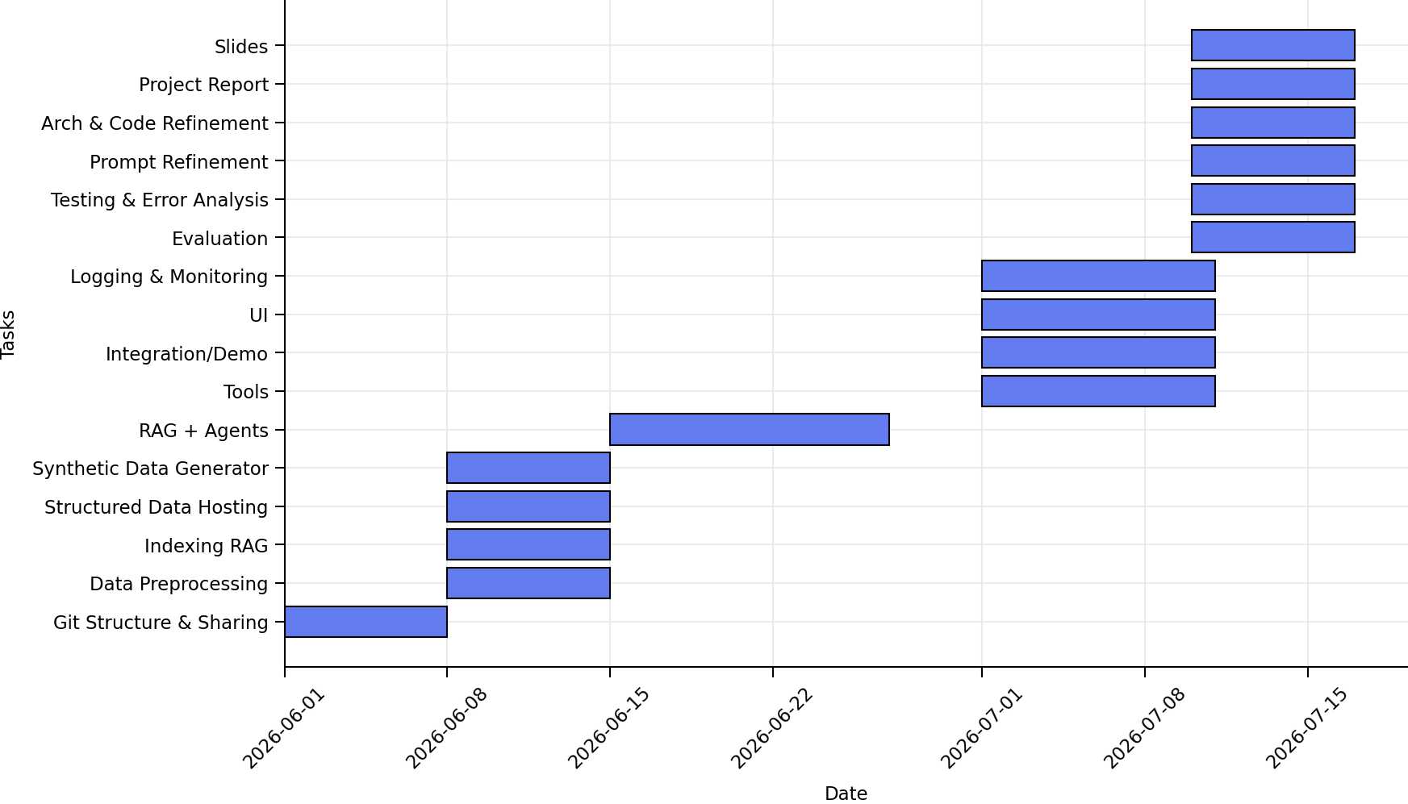

12. Team members’ names
- Soham De
- Gaurav Khamesra
- Prashant Singh
- Shourya Gupta
- Vikash Singh
- Richa Katare
- Sai Trinath
- Harshil Patel
- Chacha Srihari Kandimalla
- Rahul Raman
- Rakesh Ravikumar
- Tushar Pratim Sarma

13. Designated team coordinator's name(s): Soham De, Harshil Patel

